**Project Report**

**Project Title:** Brand Promo Video Using Canva

**Course:** Digital Marketing

**Team Members:**

Sathesh Kumar V – au311820106020

Balakrishnan s – au311820106301

Kishore R – au311820106702

Thanveer Sheriff A -au311820106025

**Introduction:**

Welcome to the world of Airpodes brand promo video where innovation meets elegance, and quality is our top priority. Join us on a journey of discovery as we unveil the essence of our brand in this exclusive promo video. From our humble beginnings to our current heights, we invite you to experience the magic that sets us apart. Get ready to be inspired, captivated, and enthralled as we introduce you to the heart and soul of Airpodes brand promo video.

**Purpose:**

It highlights the features and design of the AirPods, showcasing their functionality, comfort, and convenience.It demonstrates how AirPods can fit seamlessly into the user's daily life, emphasizing a wireless and hassle-free experience.

**Empathy Map:**

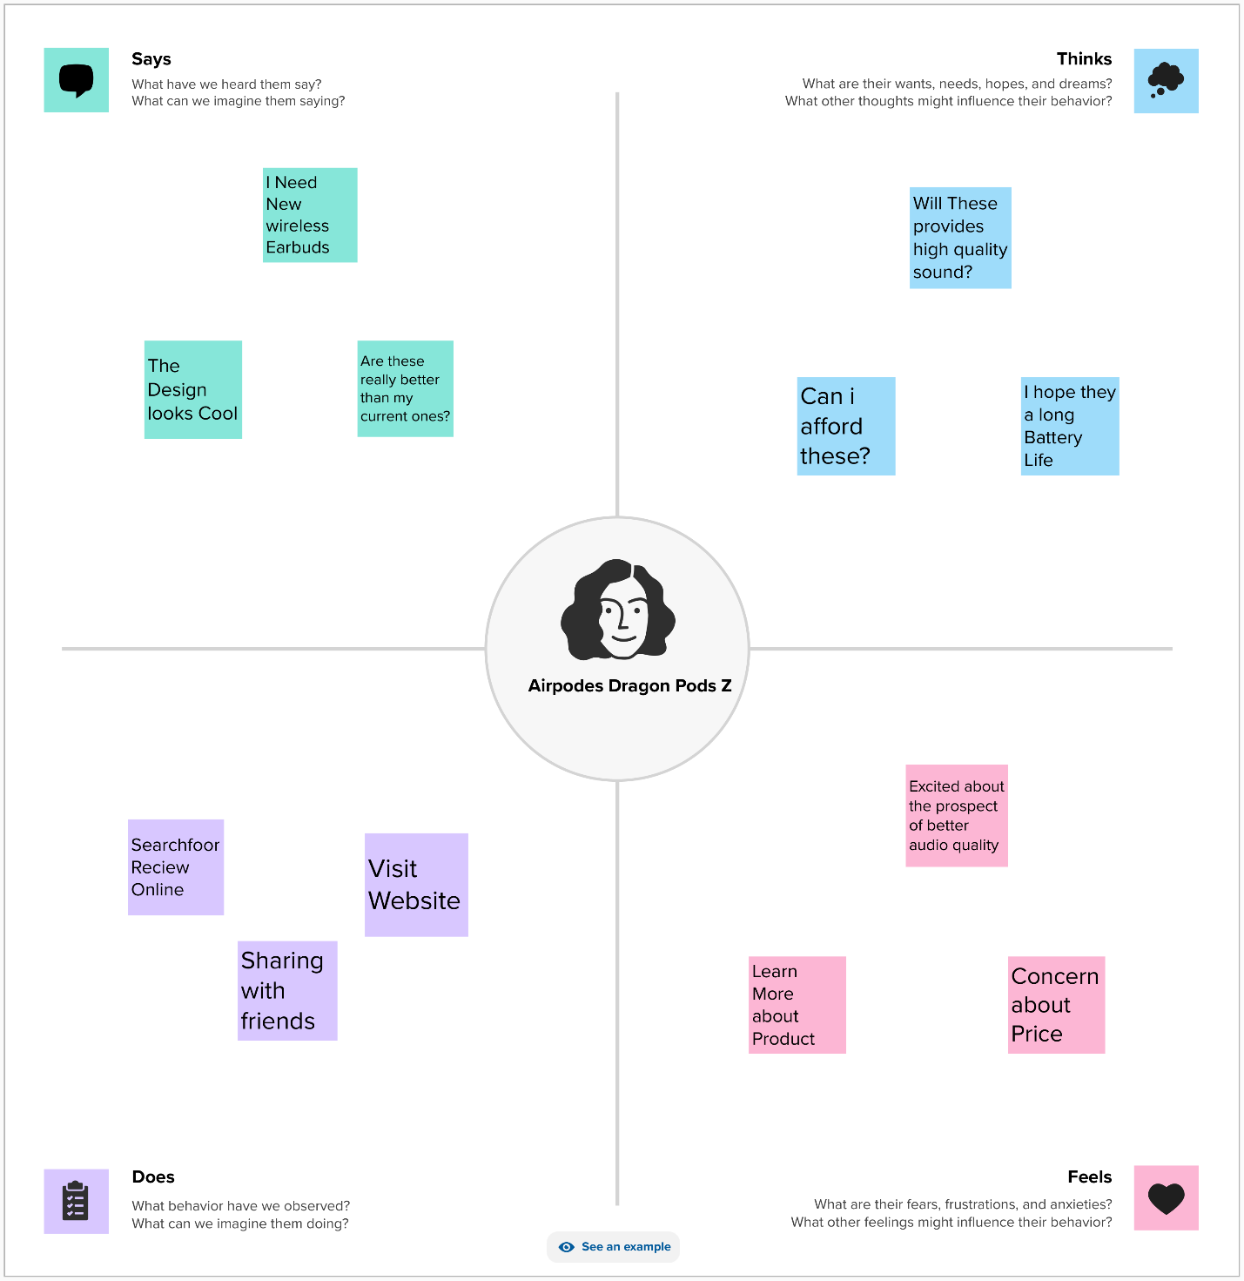

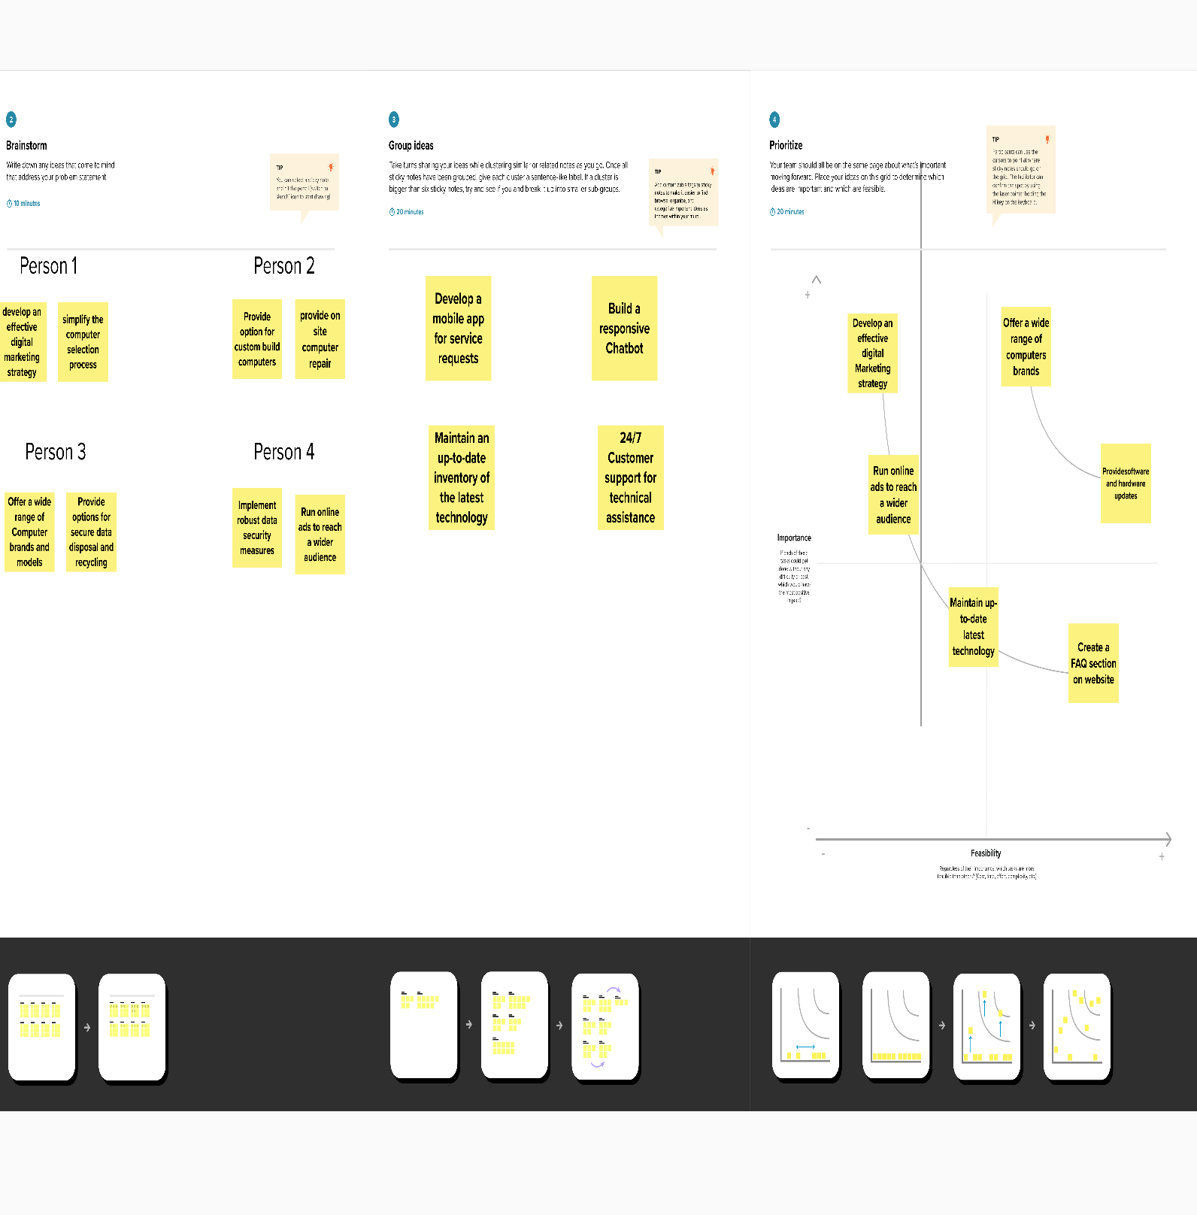

**Advantages:**

Product Demonstration: Videos can effectively showcase the design and features of AirPods, providing a clear understanding of what they offer.

Visual Appeal: High-quality visuals and animations can make the product more enticing and visually appealing.

Sound Quality: Promo videos can highlight the exceptional sound quality and audio experience that AirPods deliver.Ease of Use: Demonstrating the simplicity of pairing AirPods with Apple devices and their intuitive touch controls can be a strong selling point.

Lifestyle Integration: Videos can depict how AirPods seamlessly integrate into various aspects of a modern, connected lifestyle.

Wireless Convenience: Emphasizing the wireless nature of AirPods and their freedom from tangled cords can be a persuasive factor.Brand Trust: Leveraging Apple's reputation for quality and innovation to instill trust in potential customers.

Emotional Appeal: Creating an emotional connection with viewers through storytelling and aesthetics, making AirPods desirable and aspirational.

User Testimonials: Including user testimonials can build trust and provide real-world experiences to potential buyers.

**Disadvantage:**

Exclusivity: Apple's premium pricing and the exclusive focus on Apple devices may alienate potential customers who use non-Apple products.

Over-hype: There is a risk of over-hyping the product in promo videos, which may lead to high expectations that aren't met for some customers.

Competing with Predecessors: If a new AirPods model does not offer significant improvements over the previous version, it can be challenging to create a compelling promo video.Limited Customization: Promo videos often follow a standardized format, which may not cater to the specific needs or preferences of individual customers.

Cost: Producing high-quality promo videos can be expensive, which might affect the overall marketing budget.

Environmental Concerns: The promotion of consumer electronics like AirPods can contribute to e-waste and environmental concerns if not properly addressed.

User Experience Variability: Not all users may have the same experience as depicted in the video, which could lead to dissatisfaction.

**Conclusion:**

Inspiration in Every Beat. Dragon pods z (Airpodes) - Redefining Sound, Redefining Style. Join us on a journey of innovation, music, and freedom. Get ready to experience the future of audio. Discover the difference with dragon pods z (Airpodes)

**Future scope:**

Augmented Reality (AR) and Virtual Reality (VR): Immersive AR/VR experiences can be used to showcase the features and benefits of AirPods. Users can virtually try them on, explore their functionality, and get a feel for the product.

Social Media Integration: The integration of promotional videos with interactive features on social media platforms can help create a buzz. For instance, Instagram and Facebook filters that simulate using AirPods can engage users.

E-commerce Integration: Interactive video ads can link directly to e-commerce platforms, allowing users to make a purchase with just a few clicks while watching the video.

Personalization: Tailoring videos to individual preferences based on user data is likely to become more sophisticated. Personalized recommendations and experiences can enhance engagement.

Sustainability and CSR: Promotional videos might focus on the eco-friendly aspects of the product, showcasing the brand's commitment to sustainability, which is increasingly important to consumers.

AI Chatbots: Integrating AI chatbots into promotional videos can answer user questions in real-time and guide them through the purchase process.

User-Generated Content: Encouraging users to create and share their AirPods experiences through video contests and challenges can be a powerful marketing strategy

Appendix:

GitHub and project video demo link